**1. Software and Hardware Requirements :**

* Operating System : Windows 7 and Above
* Processor : Intel or AMD
* Ram : 2GB and Above
* Hard Disk : 50GB and Above
* Keyboard & Mouse : Yes
* Printer : (Only if hard copy is required)
* Software : Spyder or Anaconda etc.
* Software : MicroSoft Excel

**2. Modules Used :**

* **Python Pandas :-**

Pandas is an open-source Python Library providing high-performance data manipulation and analysis tool using its powerful data structures. The name Pandas is derived from the word Panel Data – an Econometrics from Multidimensional data.

In 2008, developer Wes McKinney started developing pandas when in need of high performance, flexible tool for analysis of data.

Using Pandas, we can accomplish five typical steps in the processing and analysis of data, regardless of the origin of data — load, prepare, manipulate, model, and analyze.

Python with Pandas is used in a wide range of fields including academic and commercial domains including finance, economics, Statistics, analytics, etc.

* **CSV :-**

A comma-separated values (CSV) [file](https://en.wikipedia.org/wiki/Computer_file) is a delimited [text file](https://en.wikipedia.org/wiki/Text_file) that uses a [comma](https://en.wikipedia.org/wiki/Comma) to separate values. Each line of the file is a data [record](https://en.wikipedia.org/wiki/Record_(computer_science)). Each record consists of one or more [fields](https://en.wikipedia.org/wiki/Field_(computer_science)), separated by commas. The use of the comma as a field separator is the source of the name for this [file format](https://en.wikipedia.org/wiki/File_format). A CSV file typically stores [tabular](https://en.wikipedia.org/wiki/Table_(information)) data (numbers and text) in [plain text](https://en.wikipedia.org/wiki/Plain_text), in which case each line will have the same number of fields.

The CSV file format is not fully standardized. The basic idea of separating fields with a comma is clear, but the situation gets complicated when field data also contain commas or embedded [line breaks](https://en.wikipedia.org/wiki/Newline). CSV implementations may not handle such field data, or they may use [quotation marks](https://en.wikipedia.org/wiki/Quotation_mark) to surround the field. Quotation does not solve everything: some fields may need embedded quotation marks, so a CSV implementation may include escape characters or escape sequences.

* **Datetime :-**

In Python, date and time are not a data type of its own, but a module named datetime can be imported to work with the date as well as time. Datetime module comes built into Python, so there is no need to install it externally.

Datetime module supplies classes to work with date and time. These classes provide a number of functions to deal with dates, times and time intervals. Date and datetime are an object in Python, so when you manipulate them, you are actually manipulating objects and not string or timestamps.

**3. Introduction :**

This program help in storing data of sales, viewing menu card by using CSV file and calculating bill.

With the help of this program, owner can do analysis of his sales and understand which product is being sold more and which product is being sold less.

Accordingly he can purchase more raw material of that product which is sold more and purchase less raw material for least sold product which result in efficient utilization of resources and help him to grow his business faster.

Customer can also easily see menu card, order product and get their bill at the same time from the comfort of their home, when this program is uploaded on business's website.

**4. Source Code :**

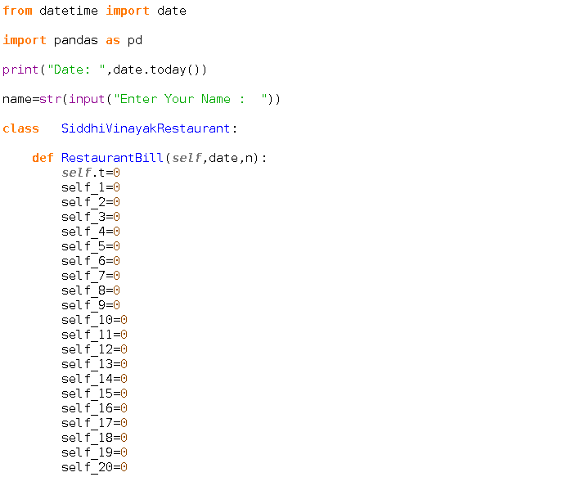

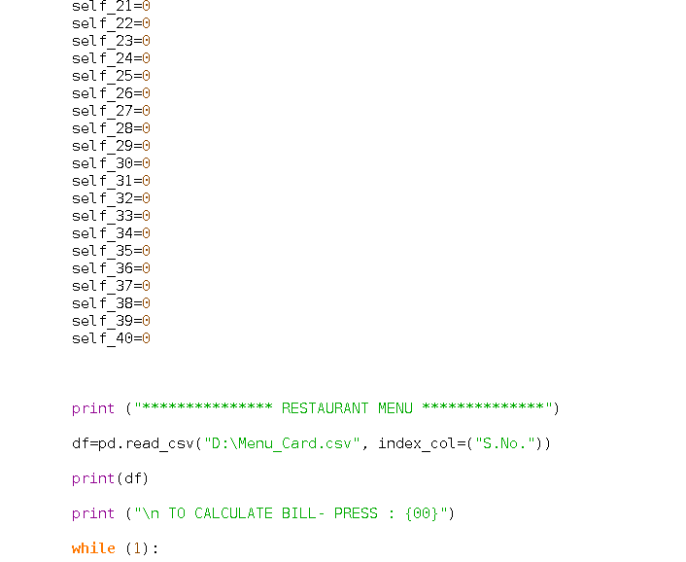

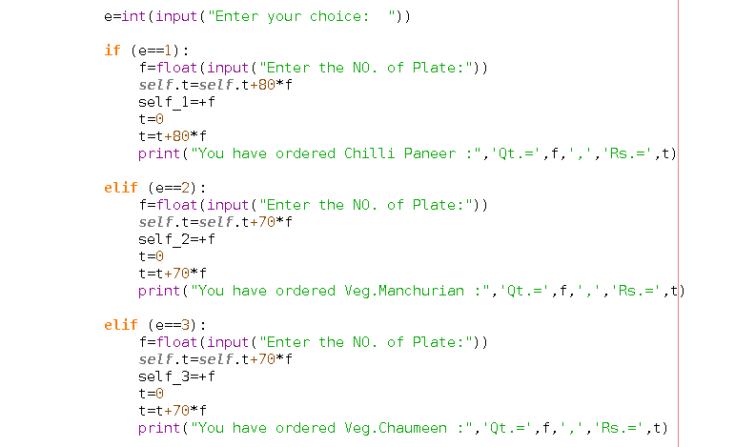 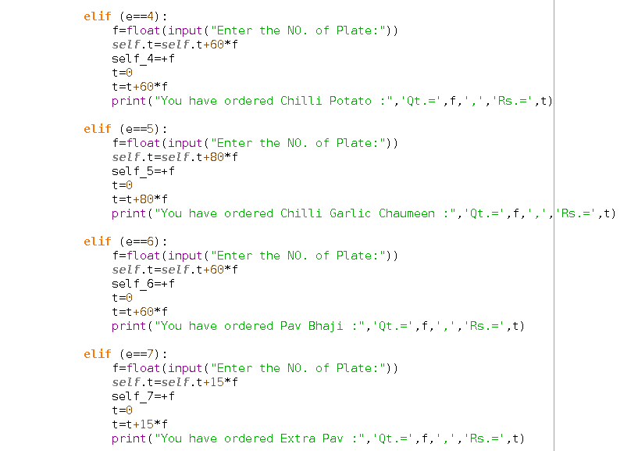 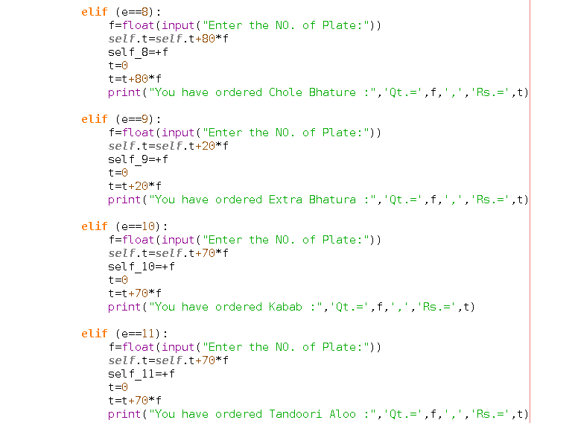 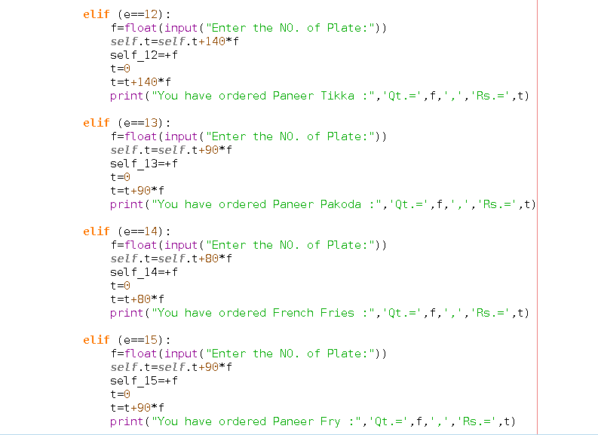 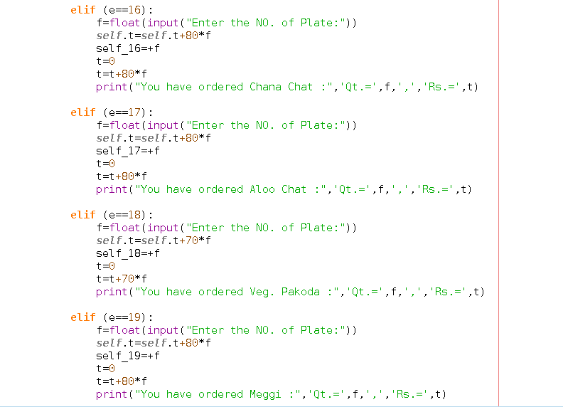 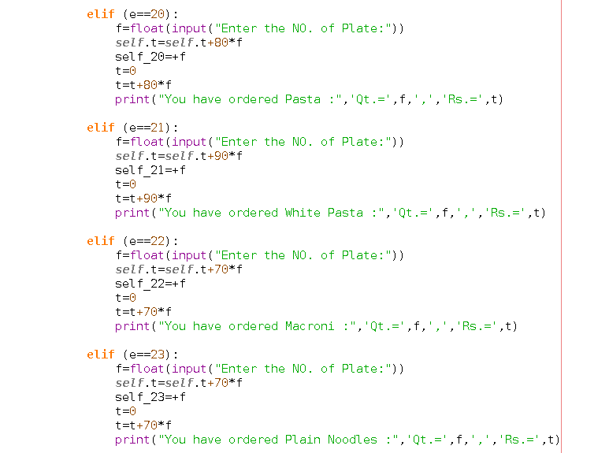 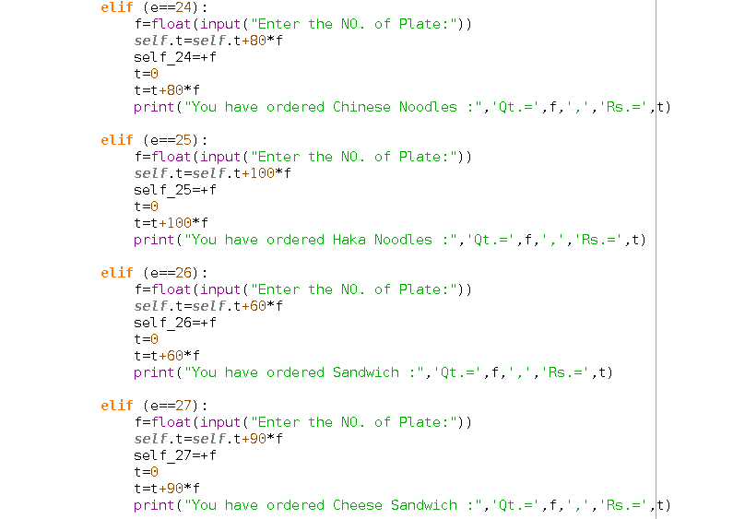 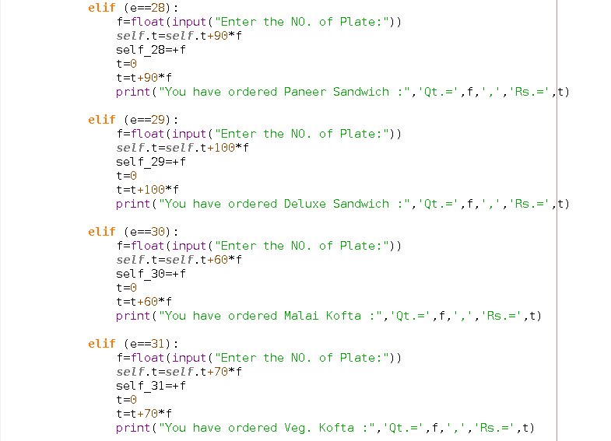 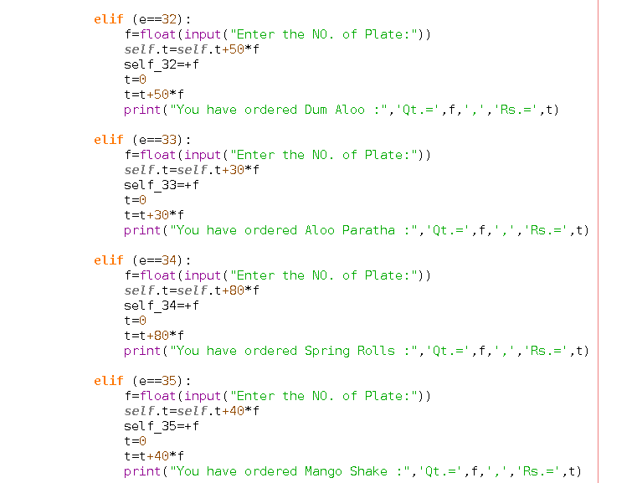 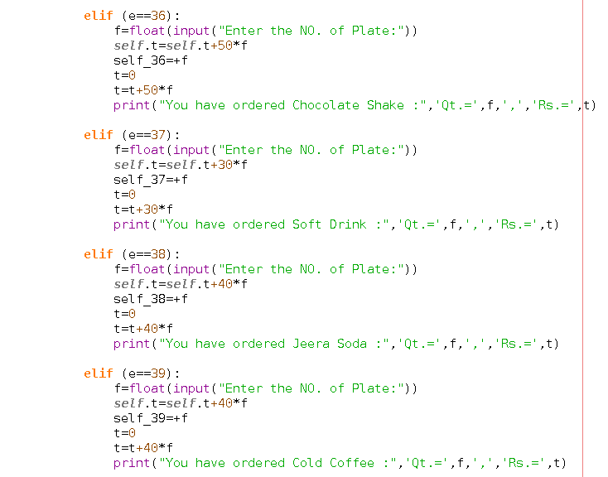 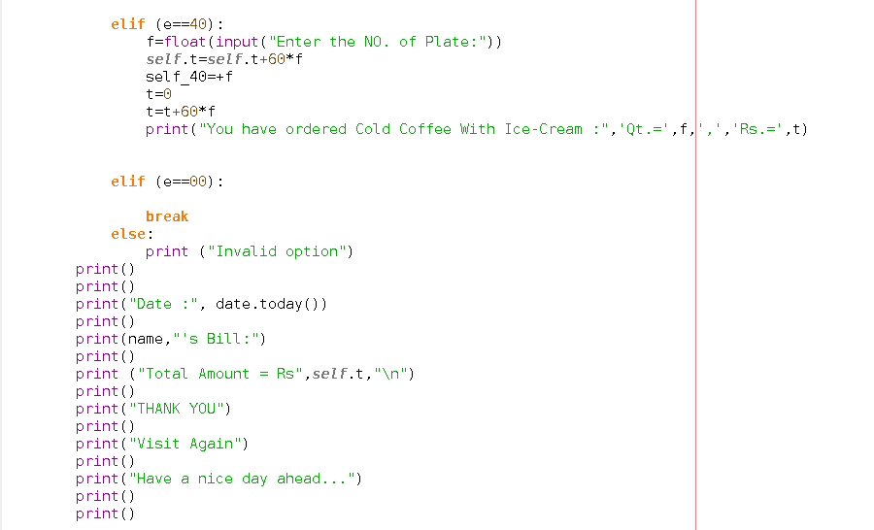 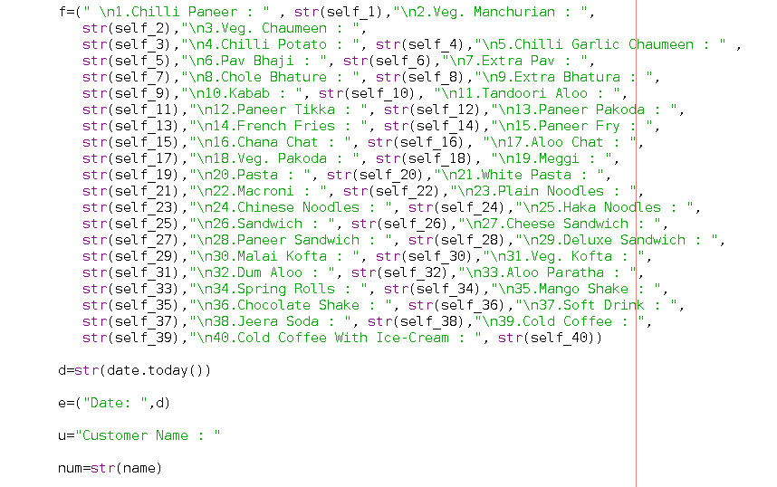 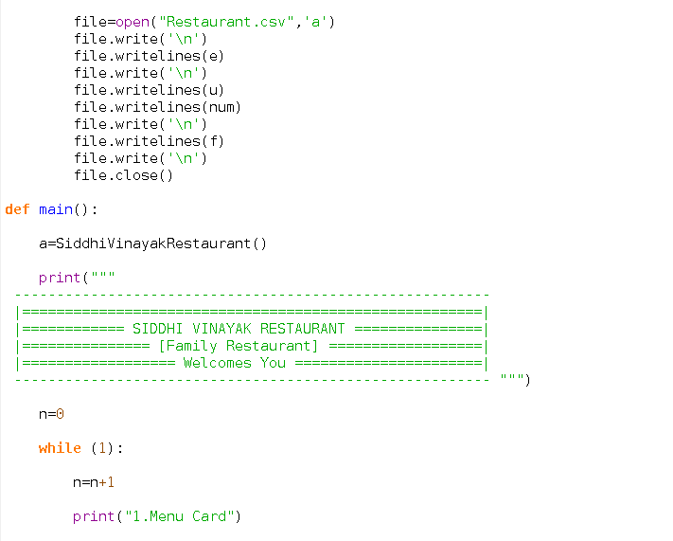 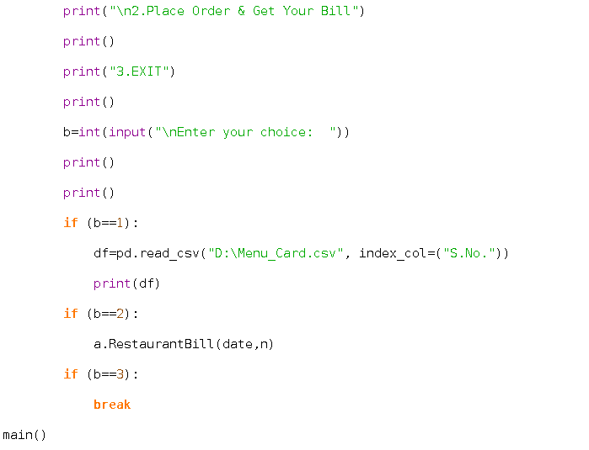

**5. Outputs :**

* Date will be shown automatically on the screen and now customer has to enter his/her name.

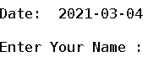

* Now welcome message will appear and 3 Options will be shown and you can choose any option according to your need.

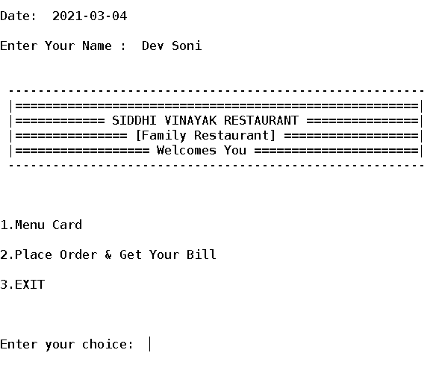

* After choosing option 1 than it will provide you with the Menu Card of the Restaurant and you can see each item and its price as well.

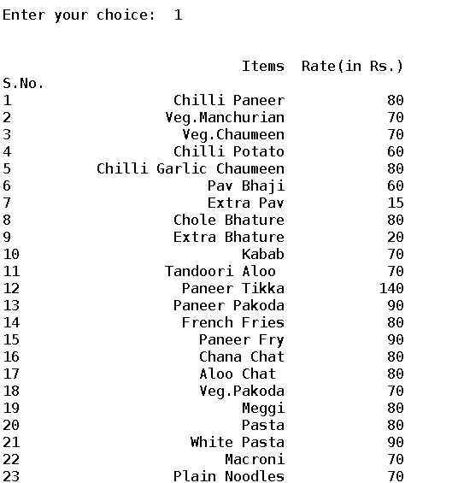

* After watching Menu Card carefully you can select option 2 for placing your order.

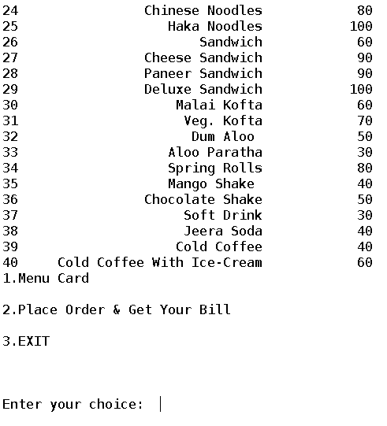

* Again Restaurant Menu has been displayed on the screen and here you can select item according to your choice.

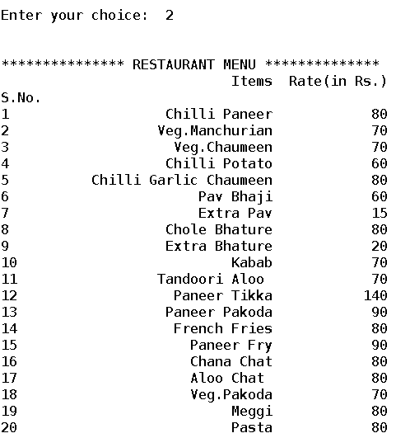

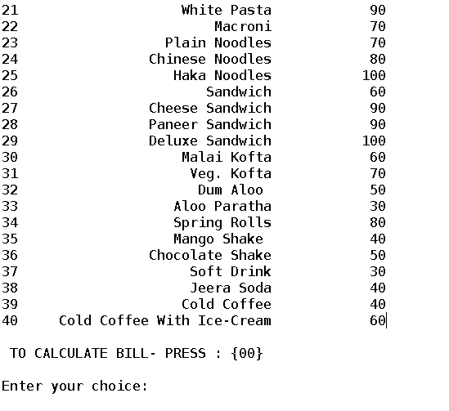

* After selecting your order, you have to place your order by entering the S.no. in front of item list and hence you can see the name, quantity and price (of particular product according to its selected quantity).

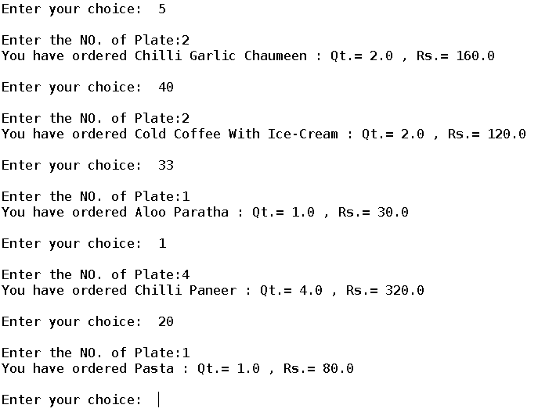

* After selecting all items, now, to Calculate your bill you have to press {00} and your bill is ready with date and your name mentioned on it.

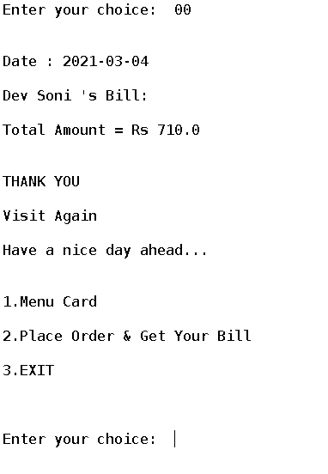

* By selecting option 3 you will exit from the program whenever you want.

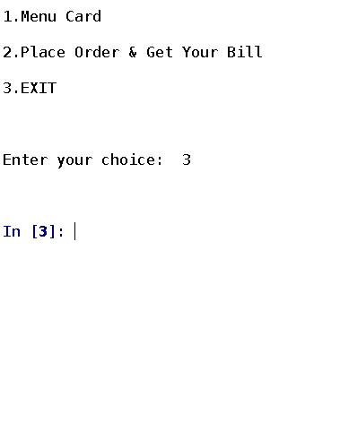

* CSV (Comma-Separated Values) File can be seen by opening it in the Microsoft Excel and you can see on which date and which customer has ordered which items easily.

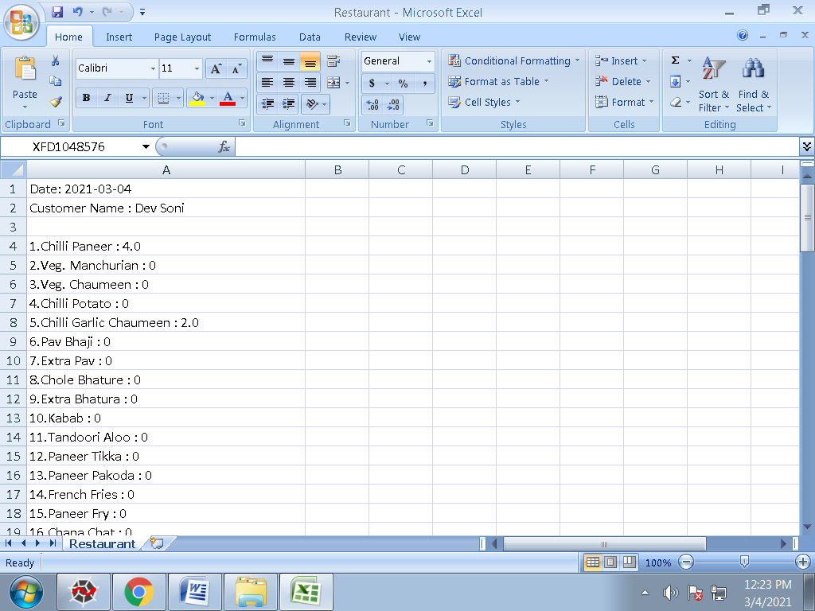

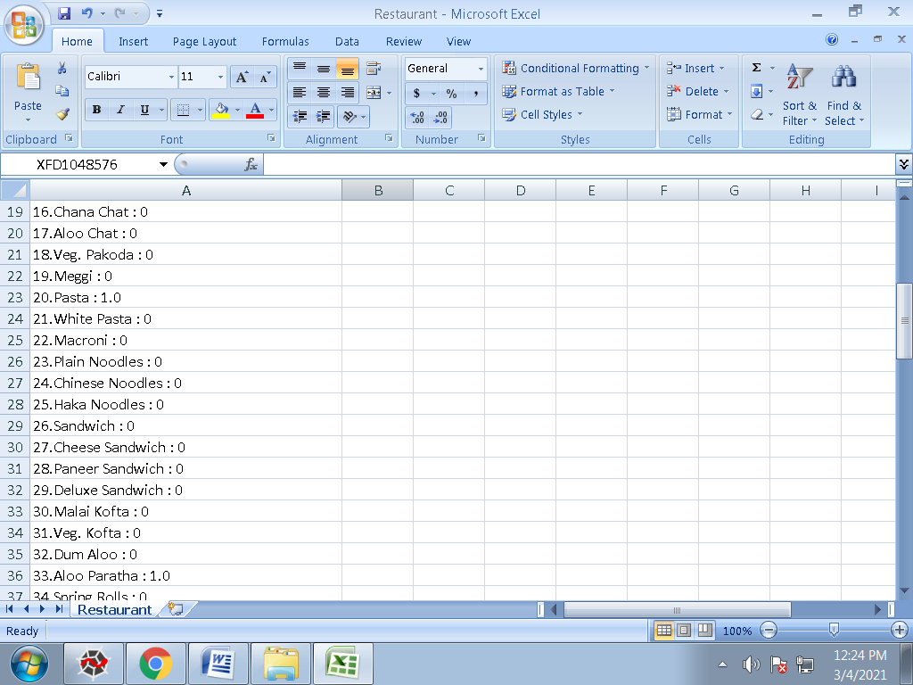

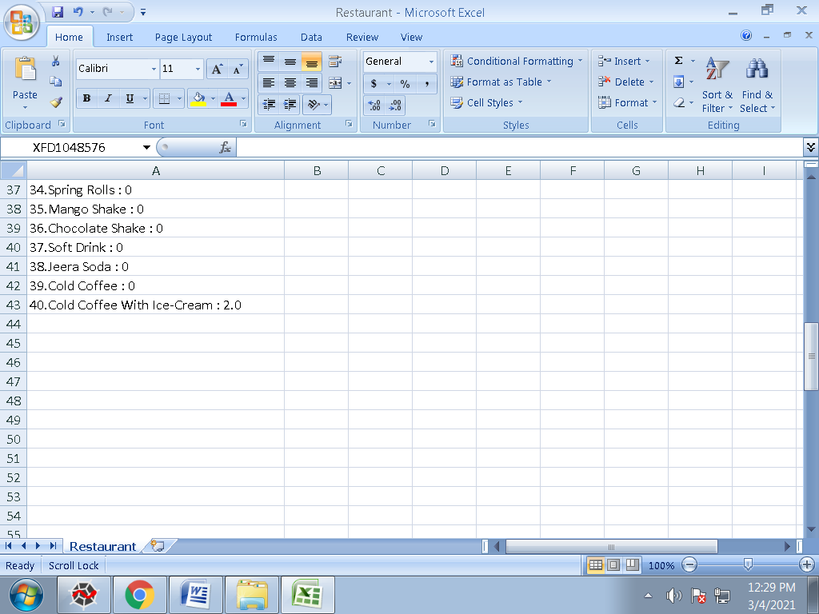

* Menu_Card (CSV File) which is used to open Menu Card in program at option 1 as well as option 2.

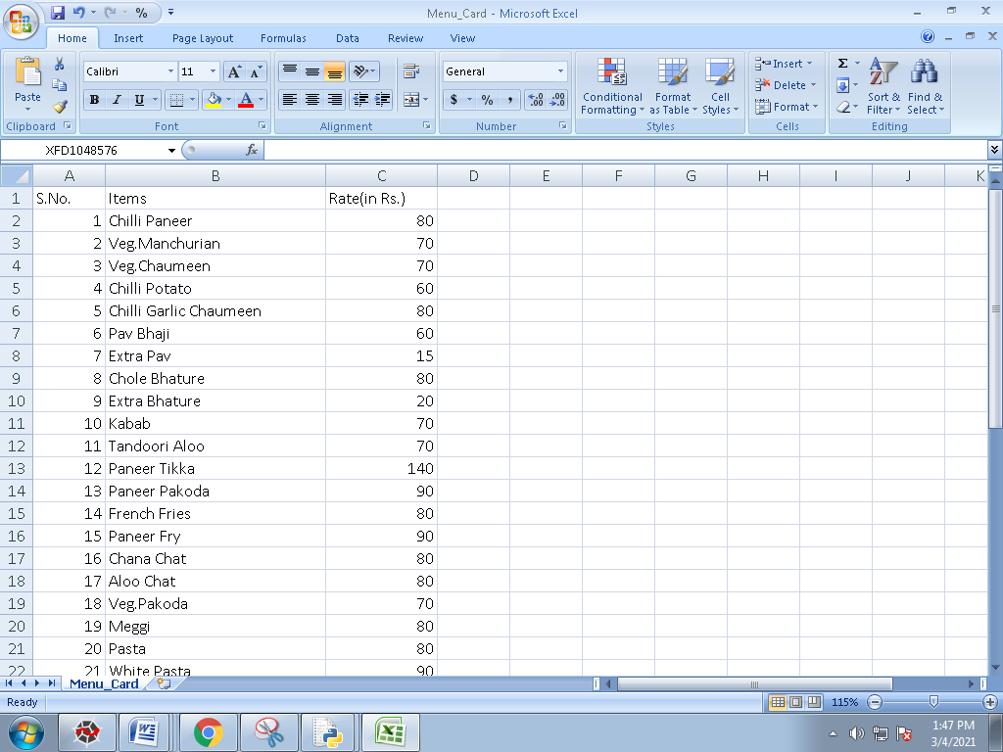

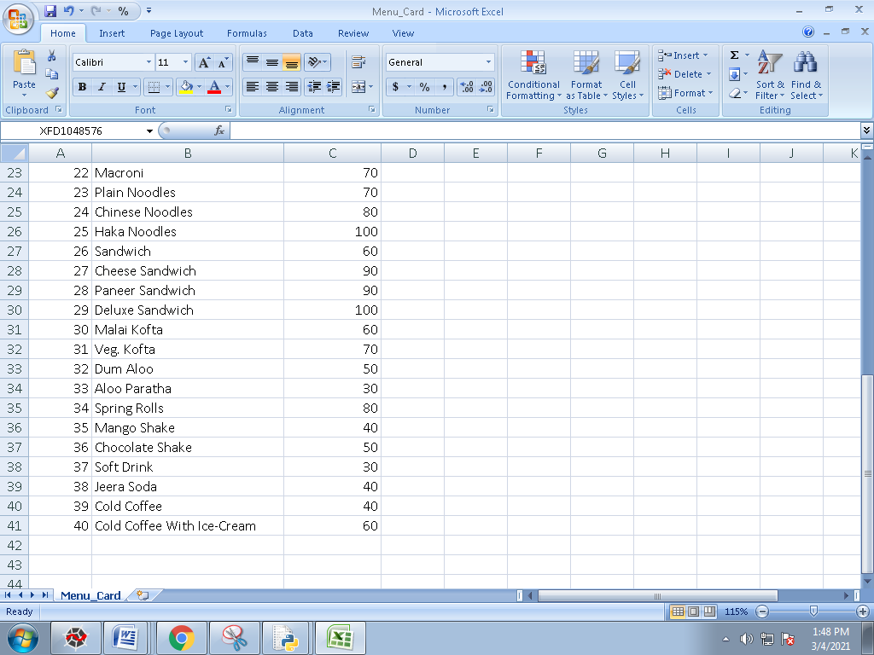

**6. Limitations :**

1. This program can be connected to python Pyplot (Matplotlib Library) through which we can visualize the data of sale on charts graph and study that data more easily which helps the shopkeeper or owner to get maximum profit as the data of sales is already saved in .csv form.
2. This program can also connected to MySQL (mysql.connecter Library) through help we can make an array in which an array of number of item sold at that date.

**7. Bibliography :**

* Sumita Arora (Textbook of Class 12th)
* Google
* Wikipedia